Creating accessible presentations in Microsoft Excel


This toolkit provides practical guidance for creating accessible Excel spreadsheets that cater to diverse user needs, including individuals with disabilities. By following these steps, creators can ensure their spreadsheets are inclusive, functional, and compliant with accessibility standards like WCAG and Section 508. Accessible spreadsheets empower all users, improve usability, and enhance data accuracy by ensuring clarity and logical structure.
Designed for professionals, educators, and anyone sharing data through Excel, this guide simplifies the process of making spreadsheets usable for everyone, including those relying on assistive technologies. Whether you’re new to accessibility or refining your skills, this toolkit equips you with essential practices to promote inclusivity in your work.

Step 1. General Accessibility Guidelines

Use Clear and Consistent Formatting
- Fonts
  - Choose sans-serif fonts like Arial, Calibri, or Verdana for better readability. Avoid serif fonts (e.g., Times New Roman) as they can be difficult to read for some people with dyslexia.
- Font Size
  - Use a minimum of 10-12pt for text, especially for headings or critical information.
- Color Usage
  - Ensure that text and background colors have high contrast. Use dark text on light backgrounds or light text on dark backgrounds. Avoid relying on color alone to convey meaning (e.g., using only red text for warnings).
- Text Emphasis
  - Use bold or italics for emphasis, but avoid overusing these styles as they may confuse screen readers.

Provide Clear Titles and Descriptions
- All documents should have a meaningful title which represents its contents. Select File → Info then type in the title.
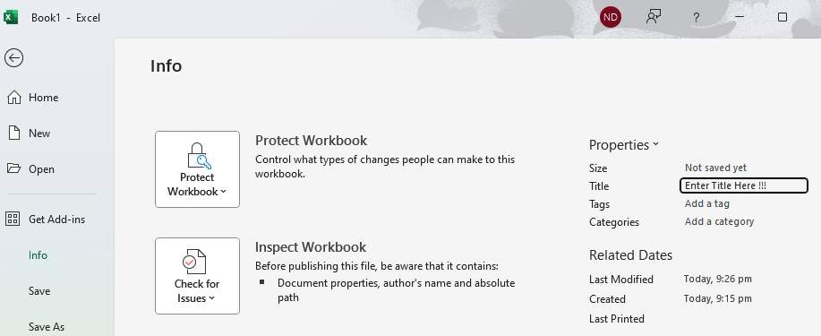
- File Name
  - Give the spreadsheet a descriptive file name that reflects its content (e.g., "2024_Quarterly_Sales_Report.xlsx").
- Sheet Titles
  - Each sheet within the workbook should have a meaningful name (e.g., "Employee Data", "Sales Summary").
  - Add Titles or Edit titles by Double clicking on the worksheet tab.

- Delete any unused worksheet by Right Click → Delete
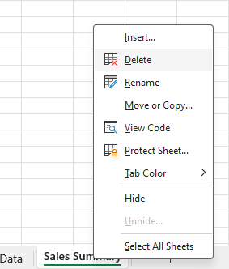
- Column and Row Headers
  - Ensure headers are clear and concise. If possible, use the first row for column headers, and the first column for row labels.

Keep Layout Simple and Logical
- Minimize Merged Cells
  - Merging cells can disrupt navigation for screen reader users. If you need to merge cells for aesthetics, ensure they don’t interfere with essential data structures like headers or tables.
- Logical Data Grouping
  - Use separate sheets or clearly separated tables for different sections of data to reduce confusion.

Step 2. Structuring Data for Accessibility

Organize Data with Headers
- Use Excel’s Table Function
  - Convert your data into a table by selecting your data range and clicking Insert → Table. This ensures that screen readers can properly interpret the data structure.
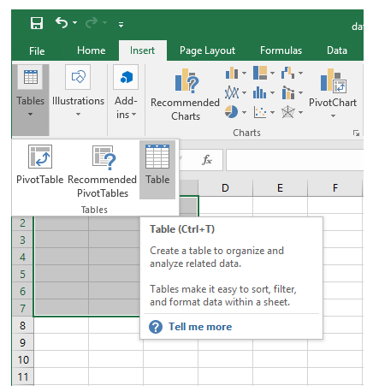
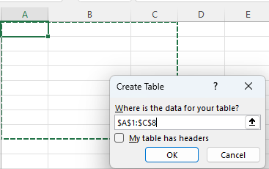
Excel creates header rows with default names Column1, Coloumn2 etc. Replace the column headers with your descriptive text.
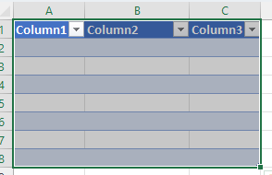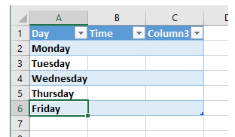
Select the cells of your table then choose Format As Table from the Styles Ribbon on the Home tab
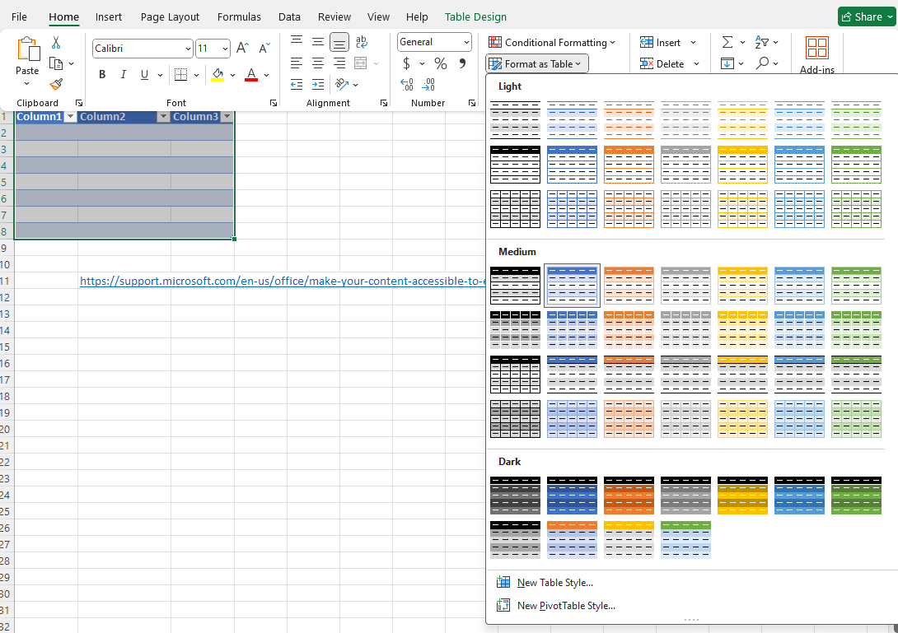
- Column Headers
  - Make sure that column headers are meaningful and concise. For instance, use "Product Name" instead of just "Name".
- Row Headers
  - If using rows of data that require explanation, label these in the first column.

Enable Data Validation and Consistency
- Dropdown Menus
  - Implement data validation with dropdown lists where possible (use Data → Data Validation). This improves consistency and reduces errors in data entry, helping users select from predefined options.
- Error Alerts
  - Set up custom error alerts if users input data incorrectly (e.g., text instead of numbers).
- Consistent Formatting
  - Ensure that data formats (like dates, numbers, percentages) are consistent across the entire sheet to prevent confusion.

Use Descriptive Text for Hyperlinks
- Instead of using URLs like "http://www.example.com", use descriptive text such as “Click here for the sales report”.
- To edit a hyperlink, right-click on the cell, select Edit Hyperlink,
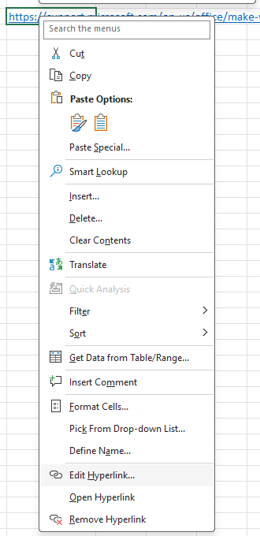
Then edit the descriptive text accordingly
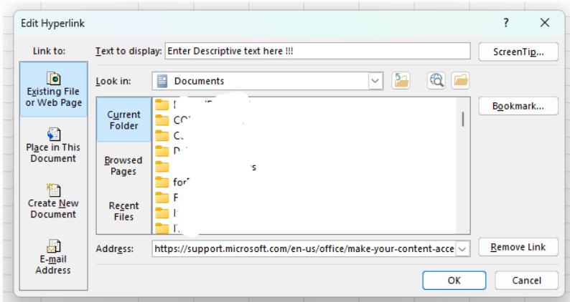

Step 3: Making Excel Sheets Screen Reader-Friendly

Add Alt Text to Charts and Images
- Charts
  - Right-click on the chart → Edit Alt Text. Provide a concise description of what the chart represents, including key trends or data points.
- Images
  - Right-click the image → Edit Alt Text. Provide a detailed description of the image’s content and context to ensure users understand its relevance.

Define Table Regions
- Using Named Ranges
  - Use Excel’s Name Manager to define ranges for key data areas (Formulas → Name Manager → New). For example, name the data for “Sales Region” as "Sales_Region_2024".

- Tables for Data
- Convert important data ranges into tables so that screen readers can easily recognize them as distinct entities. Use Insert → Table.

Use Accessible Names for Cells and Ranges
- Use the Name Box to define meaningful names for specific cells (e.g., "TotalSales" for a cell containing total sales figures).
- To avoid confusion, ensure that named ranges are not overly complex and accurately reflect the content.

Step 4: Navigability

Ensure Logical Tab Order
- Logical Navigation
- Ensure that the tab order follows the logical flow of your spreadsheet. Users should be able to use the Tab key to move through the spreadsheet in a natural, sequential order.
- Check with Screen Reader
- Test the tab order by navigating using only the Tab and Shift + Tab keys. This will help ensure that users can efficiently navigate the data.

Use Freeze Panes for Context
- If you have a large dataset, use View → Freeze Panes to keep headers visible as users scroll through the sheet. This allows users to maintain context as they move through the data.
- Freezing Rows: Freeze the top row to keep column headers visible, or freeze the first column for row labels if needed.

Provide Instructions for Users
- Include a dedicated "Instructions" tab at the beginning of the workbook that explains how to use the document, especially for complex or dynamic sheets.
- Instructions should be concise, written clearly, and available in alternative formats (e.g., text, video).

Step 5: Accessibility Checker

Run the Built-In Accessibility Checker
- Excel has a built-in Accessibility Checker that can help you identify potential issues. To run it:
File → Info → Check for Issues → Check Accessibility.

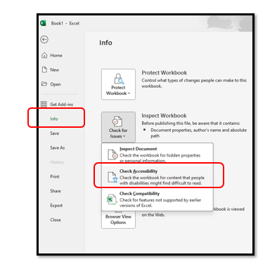
Or go through Review → Check Accessibility.
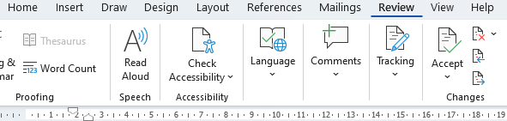
- Review the recommendations and make necessary changes to improve accessibility.
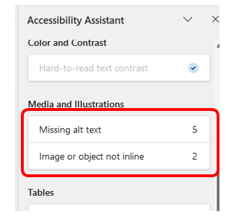

Test with Assistive Technology
- Use screen readers like NVDA, JAWS, or Narrator to test how the Excel sheet is interpreted.
- You can also simulate keyboard navigation to check that all interactive elements (like buttons, dropdowns, and hyperlinks) are usable by keyboard alone

Additional Links
Other helpful links for additional information to creating accessible PowerPoint Presentations
- https://webaim.org/techniques/powerpoint/
- https://support.microsoft.com/en-us/office/make-your-powerpoint-presentations-accessible-to-people-with-disabilities-6f7772b2-2f33-4bd2-8ca7-dae3b2b3ef25
- https://www.washington.edu/accessibility/documents/creating-accessible-presentations-in-microsoft-powerpoint/
- Microsoft PPPT accessibility guide
- 10 principles for accessibility of presentations from Perkins International.

