Creating accessible presentations in Microsoft Powerpoint


Microsoft PowerPoint is a presentation tool included in the Office 365 suite, a subscription-based collection of applications by Microsoft. It is available as both a desktop application and a web-based version, compatible with major platforms like Windows and macOS. While the accessibility features outlined below are applicable to both versions, certain functionalities may differ depending on the PowerPoint version and operating system. These accessibility recommendations are particularly focused on improving screen reader navigation.

Setting Document Properties
a. Tailor your content to your audience by using straightforward language and concise sentences.
b. Limit each slide to essential information only. When needed, divide text across multiple slides—aim to present one idea or concept per slide for clarity.

Step 1. Use an Accessible Template
- Choose built-in PowerPoint slide layouts (e.g., Title Slide, Content Slide) instead of custom layouts.
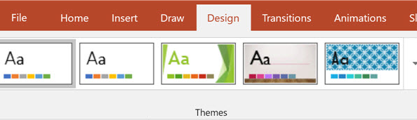
- These layouts are optimized for screen readers and assistive technologies.
- Go to Home > New Slide and pick a simple, standard layout.
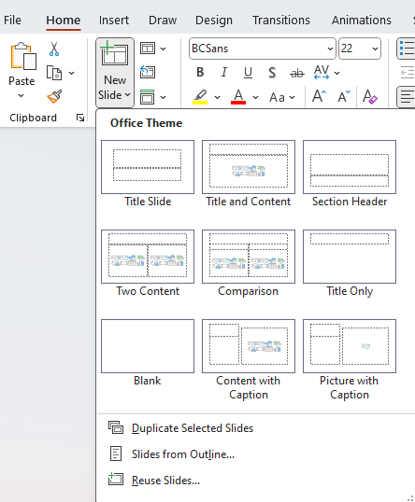

Step 2. Use Clear and Simple Text
- Font Size
  - Ensure body text is at least 18pt. Use 24pt or larger for titles and headers.
- Font Style
  - Use clear, sans-serif fonts like Arial, Calibri, or Verdana for better readability.
- Line Spacing
  - Set line spacing to 1.5 or higher for better legibility.
- Contrast
  - Use high contrast between text and background. For example, black text on a white background or white text on a dark background.
- Avoid text-heavy slides; use bullet points to summarize key ideas.

Step 3. Add Alternative Text (Alt Text) for Visuals
Enter an image description (short but meaningful).
Descriptions will be read-aloud by a screen reader helping users who have difficulty seeing the content.

- Images: Right-click on images and select View Alt Text...
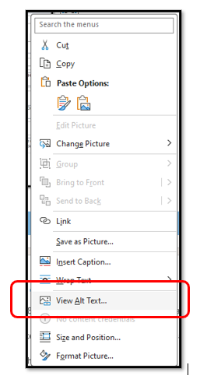
  - Describe the image, its purpose, or context.
  - Keep descriptions concise but informative (e.g., “A graph showing the increase in sales over 5 years”).
- Charts & Graphs
  - Add alt text describing trends, patterns, or
  - key data points.
- Shapes & Icons
  - Provide alt text for decorative icons or shapes if they convey meaning (e.g., “icon of a person in a wheelchair”).

Mark non-essential visual elements as decorative.
- Right click on any visual element > click “Edit Alt Text” > Check the box “Mark as decorative”.
Why? This means that a screen reader will completely ignore this non-essential visual element, which will make the document much more navigable.
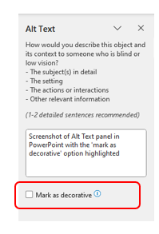

Step 4. Use High Contrast Colors
The PPT accessibility checker will help you by displaying a warning if the contrast between the color of your text and the color of your background does not meet the requirements for persons with visual impairments; your target contrast should be a 3:1 ratio.
- Background Color: Choose simple backgrounds with contrasting text.
- Avoid: Low contrast colors like red/green or blue/yellow, which are difficult for colorblind users.
- Recommended Color Pairs:
  - Black text on white background
  - White text on dark blue background
  - Yellow text on blue background

Step 5. Don’t Rely on Color Alone
- If conveying information through color, also use labels, icons, or patterns.
- Example: Instead of "Click the blue link," say “Click the blue link with the label ‘More Information’.”
- Use symbols like checkmarks or exclamation points to help those who cannot differentiate colour.
After
Before

Step 6. Provide Descriptive Hyperlinks
- Avoid just listing URLs. Use descriptive text for hyperlinks.
- Example: Instead of saying “Visit www.example.com,” say “Learn more about our services here”.
- Insert hyperlinks using Insert > Link.

Step 7. Add Closed Captions and Subtitles for Videos
- Ensure that videos have captions or transcripts.
- Use PowerPoint’s subtitling tool for videos or insert an accessible video format with captions.
- Add a transcript of spoken content if you can't include captions.

Step 8. Use Slide Titles
- Every slide should have a unique title that accurately describes the content of the slide.
- This helps screen readers navigate content quickly.
- Avoid blank or generic slide titles like "Slide 1" or "New Slide."

Step 9. Create Accessible Tables
- Simple Tables: Keep tables simple; avoid splitting or merging cells.
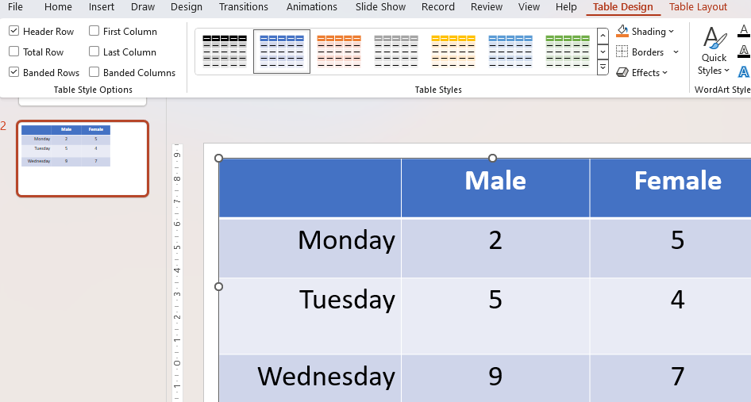
- Table Headers: Label columns and rows clearly, making sure they are easily understood by screen readers.
- Use Header Row functionality for better table structure.
- Alt Text for Tables: Right-click the table and select Edit Alt Text to explain its purpose.

Step 10. Check the Reading Order
- Check Order: Ensure content is read in the right sequence by assistive technologies.
- Go to Home > Arrange > Selection Pane to adjust the reading order of objects.
- Arrange elements from top to bottom or left to right.

Step 11. Use the Built-in Accessibility Checker
PowerPoint has a built-in Accessibility Checker:
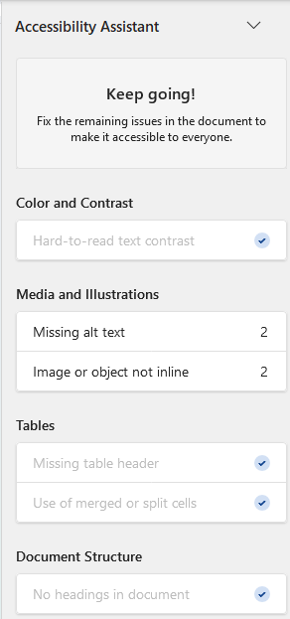
- Go to Review > Check Accessibility.
- Review the issues and follow PowerPoint’s suggestions to fix them (e.g., adding alt text, improving contrast).

Step 12. Test Your Presentation with Screen Readers
- Test with Narrator (Windows) or VoiceOver (Mac) to ensure your presentation works well with screen readers.
- Review your slides using keyboard shortcuts (e.g., Tab to navigate through content).
- Ensure all interactive elements, like hyperlinks, are accessible.

Step 13. Use Simple and Consistent Layouts
- Avoid excessive animations or transitions, as these may be distracting or hard to follow.
- Stick to simple, easy-to-navigate layouts and use consistent fonts and colors.

Step 14. Ensure Content is Keyboard-Navigable
- Avoid relying on mouse interactions. Ensure all content is accessible via keyboard (Tab, Shift+Tab, Enter, and spacebar).
- Test navigation by tabbing through each element to ensure users can interact with all slides.

Additional Links
Other helpful links for additional information to creating accessible PowerPoint Presentations
- https://webaim.org/techniques/powerpoint/
- https://support.microsoft.com/en-us/office/make-your-powerpoint-presentations-accessible-to-people-with-disabilities-6f7772b2-2f33-4bd2-8ca7-dae3b2b3ef25
- https://www.washington.edu/accessibility/documents/creating-accessible-presentations-in-microsoft-powerpoint/
- Microsoft PPPT accessibility guide
- 10 principles for accessibility of presentations from Perkins International.

