Creating accessible PDFs



Step 1: Setting Document Properties
Proper document properties improve accessibility by providing essential information about the document to screen readers and other assistive technologies.

Document Title
- Go to File > Properties or Info.
- In the Properties panel, add a descriptive Title for the document, author name, and relevant keywords in the Subject field.
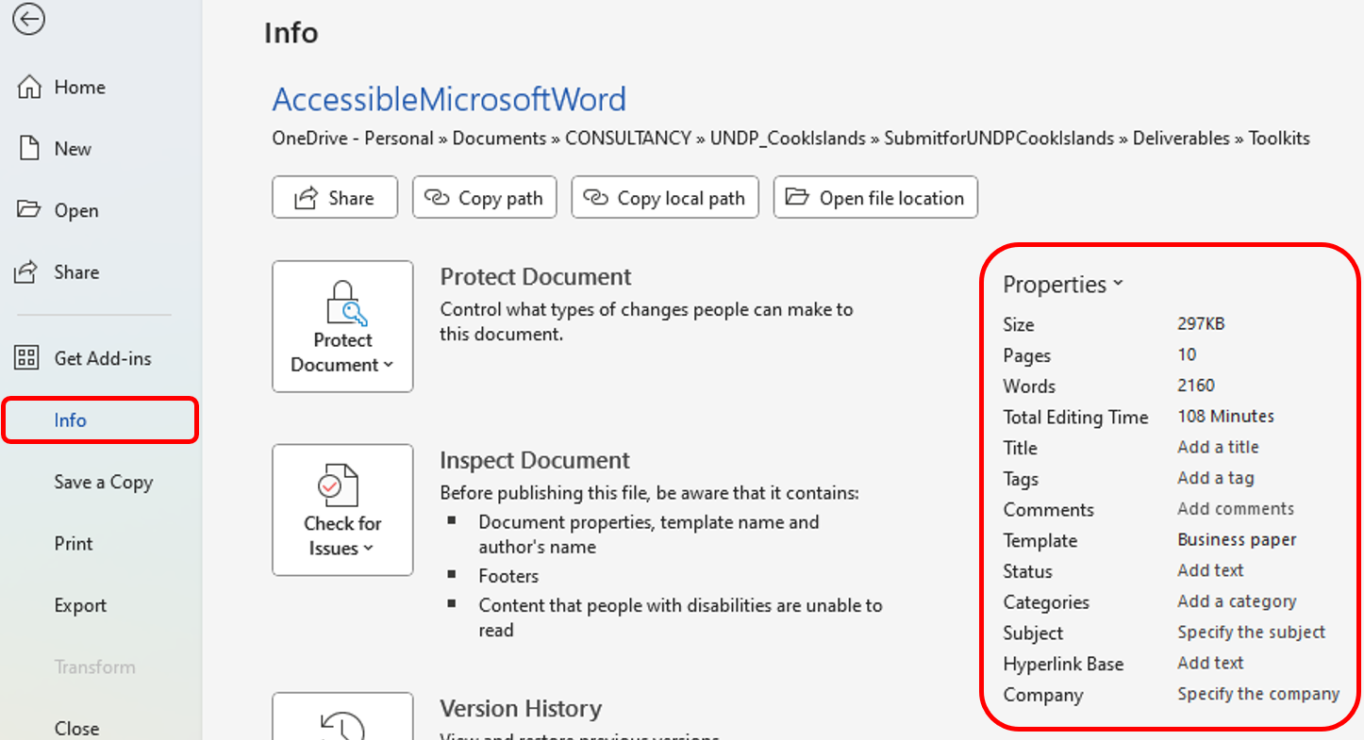
Figure 1 Info properties of Microsoft Word showing where to edit fields such as Title, Author and Subject details of the document.

Language:
- Set the document language so that screen readers correctly interpret and pronounce the text.
- Go to Review > Language > Set Proofing Language and choose the appropriate language.
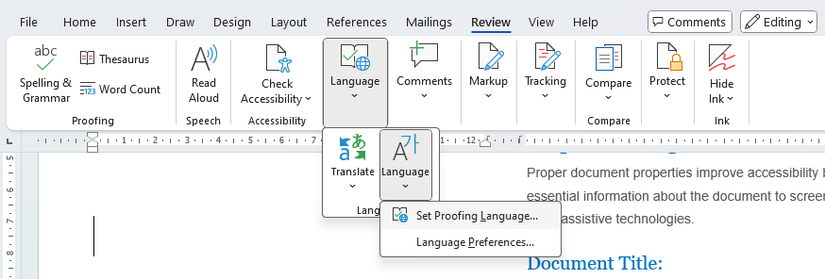
Figure 2 Reference Command and where to change Language of the document for correct interpretation by assistive technologies.

Step 2: Using Styles for Consistent Formatting
Using built-in styles ensures that headings, body text, and lists are structured for easy navigation by screen readers and other assistive technologies.
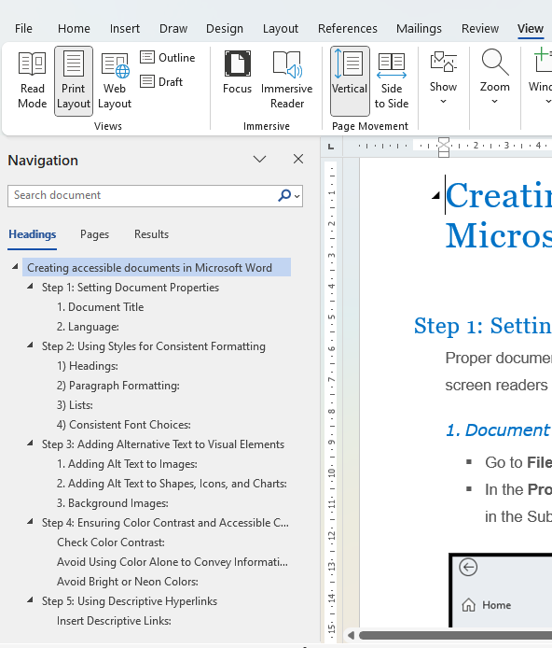

Headings:
Use Word’s built-in heading styles (Heading 1, Heading 2, etc.) to structure the document rather than manually formatting text to act as headings. This will make navigating the document by a screen reader easier.
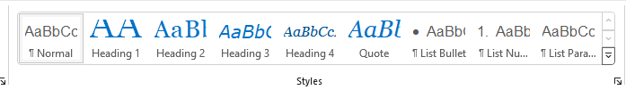
- Go to the Home tab, select a line of text, and apply a style by clicking on the appropriate style in the Styles gallery.
- Maintain a logical hierarchy: Heading 1 for main titles, Heading 2 for sections, and Heading 3 for subsections.
- Using the Navigation Pane is really helpful when applying Heading styles.

- 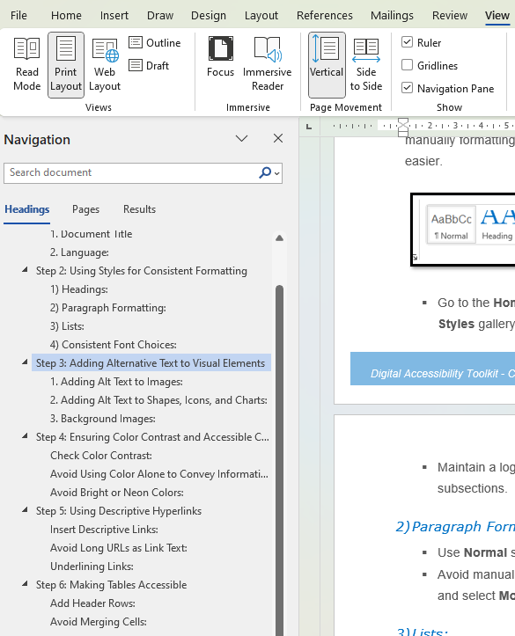
Click on the view tab and then select navigation pane to open the window which displays the list of all headings in the document.

Paragraph Formatting:
- Use Normal style for body text to ensure it’s readable and formatted consistently.
- Avoid manually adjusting spacing; instead, set spacing in Paragraph Settings (right-click on the style and select Modify).

Lists:
- Use Word’s bulleted or numbered list tools to create lists, ensuring that screen readers recognize the list structure.
- Go to Home > Paragraph and choose Bullets or Numbering.

Consistent Font Choices:
- Use readable fonts like Arial, Calibri, or Verdana at a minimum 12-point size.
- Avoid excessive use of bold, italics, or underline for readability.

Step 3: Adding Alternative Text to Visual Elements
Alternative text (alt text) provides a description of images and visual elements, which screen readers read aloud to users with visual impairments.

Adding Alt Text to Images:
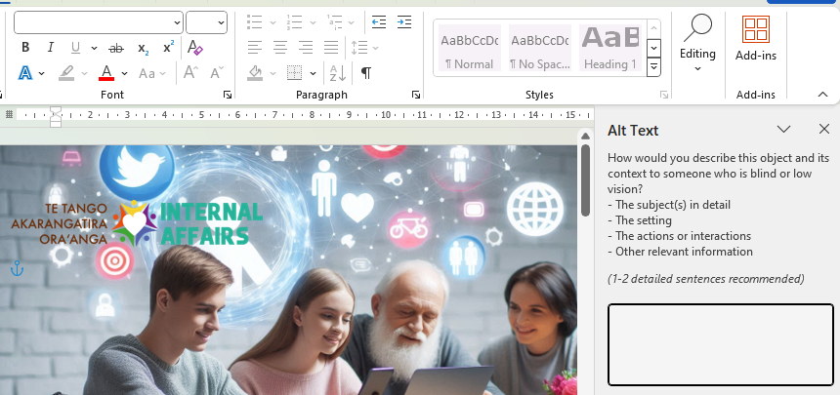
- Right-click on an image and select Format Picture.
- In the Alt Text panel, write a short, descriptive sentence that explains the content or purpose of the image.
- Example: For a pie chart showing sales, say “Pie chart displaying sales breakdown: 40% Product A, 35% Product B, and 25% Product C.”

Adding Alt Text to Shapes, Icons, and Charts:
- Follow the same steps as above for any shapes, icons, or charts in the document.
- Include descriptions that provide insight into the visual data, without overly detailing every element.

Background Images:
- Avoid using background images if possible, as they may interfere with readability.
- If necessary, add a brief description of the background image’s purpose in the alt text field.

Step 4: Ensuring Color Contrast and Accessible Color Use
Color contrast affects readability, particularly for users with visual impairments.

Check Color Contrast:
- Use a color contrast checker tool (such as WebAIM Contrast Checker) to ensure a minimum contrast ratio of 4.5:1 for text over background.
- Adjust text color or background color as needed.
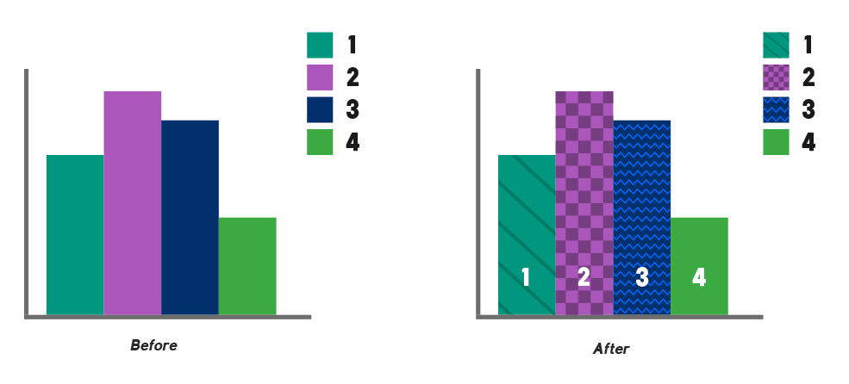

Avoid Using Color Alone to Convey Information:
Supplement color with text, patterns, or symbols for clarity.

Before
After
Example: Instead of saying “click the green button,” say “click the green ‘Submit’ button.”

Avoid Bright or Neon Colors:
Stick to neutral or mild colors for backgrounds and avoid bright or neon tones, which can be hard on the eyes.

Step 5: Using Descriptive Hyperlinks
Descriptive hyperlinks provide users with a clear understanding of the link’s purpose, improving usability and accessibility.

Insert Descriptive Links (we will use https://www.intaff.gov.ck/ as an example)
Highlight the text to turn into a hyperlink and press Ctrl+K or go to Insert > Link.
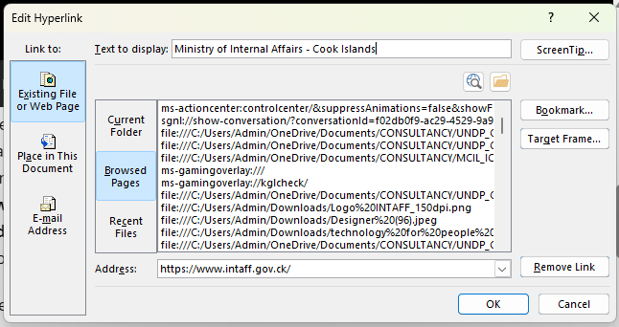
Enter the URL and type a short, meaningful description in the Text to Display field.
Example: Instead of linking “click here,” write “Read our Accessibility Guide.”

Avoid Long URLs as Link Text:
URLs can be confusing when read by a screen reader. Avoid using raw URLs as link text.

Underlining Links:
Underline hyperlinks and ensure they have a contrasting color from surrounding text to make them easily identifiable.

Step 6: Making Tables Accessible
Tables are often challenging for screen readers, so they need special attention to ensure accessibility.

Add Header Rows:
Highlight the table, go to Table Design > Header Row to designate the first row as headers.
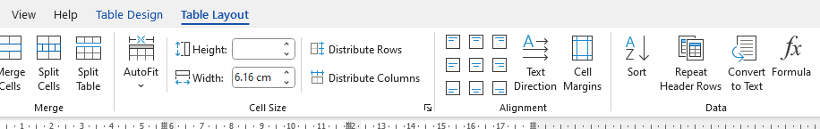
Label headers to clarify data context.

Avoid Merging Cells:
Merged cells can cause issues with screen readers. If possible, keep cells distinct and avoid merging or splitting.

Alt Text for Tables:
Right-click on the table, select Table Properties, go to Alt Text tab, and provide a brief description of the table’s content and purpose.

Simple Structure:
Avoid overly complex tables; simpler structures are easier to interpret for screen readers.

Step 7: Using the Accessibility Checker
Microsoft Word has a built-in Accessibility Checker that helps identify and resolve common accessibility issues.

Run the Accessibility Checker:
Go to Review > Check Accessibility.
Word will generate a report listing potential accessibility issues and how to address them.

Fix Common Errors:
Address issues like missing alt text, unclear headings, and inconsistent structure.
Review the suggestions provided and apply fixes as recommended.

Use Feedback:
Use the Accessibility Checker regularly, especially before finalizing a document for distribution.

Step 8: Additional Accessibility Considerations

Simplify Language:
Write in plain language and avoid jargon or technical terms that may be unfamiliar to all readers.

Use Accessible Templates:
Starting with an accessible template ensures consistent application of accessible design principles.

Keyboard Navigation:
Test the document using only keyboard commands (such as Tab, Enter, and Arrow keys) to ensure that it can be navigated without a mouse.

Exporting as Accessible PDF:
When exporting to PDF, ensure accessibility features are preserved.
Go to File > Save As and choose PDF. In the PDF options, select Document structure tags for accessibility.
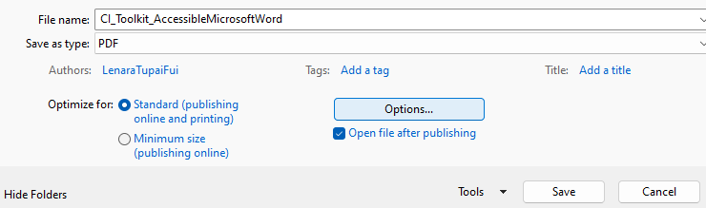
By following these detailed steps, you can create Microsoft Word documents that are accessible, ensuring inclusivity and usability for all users, including those relying on assistive technologies.

Additional Links
Other helpful links for additional information to creating accessible word documents.
- https://www.gov.wales/how-create-accessible-word-documents
- https://webaim.org/techniques/word/
- https://support.microsoft.com/en-us/office/make-your-word-documents-accessible-to-people-with-disabilities-d9bf3683-87ac-47ea-b91a-78dcacb3c66d

