
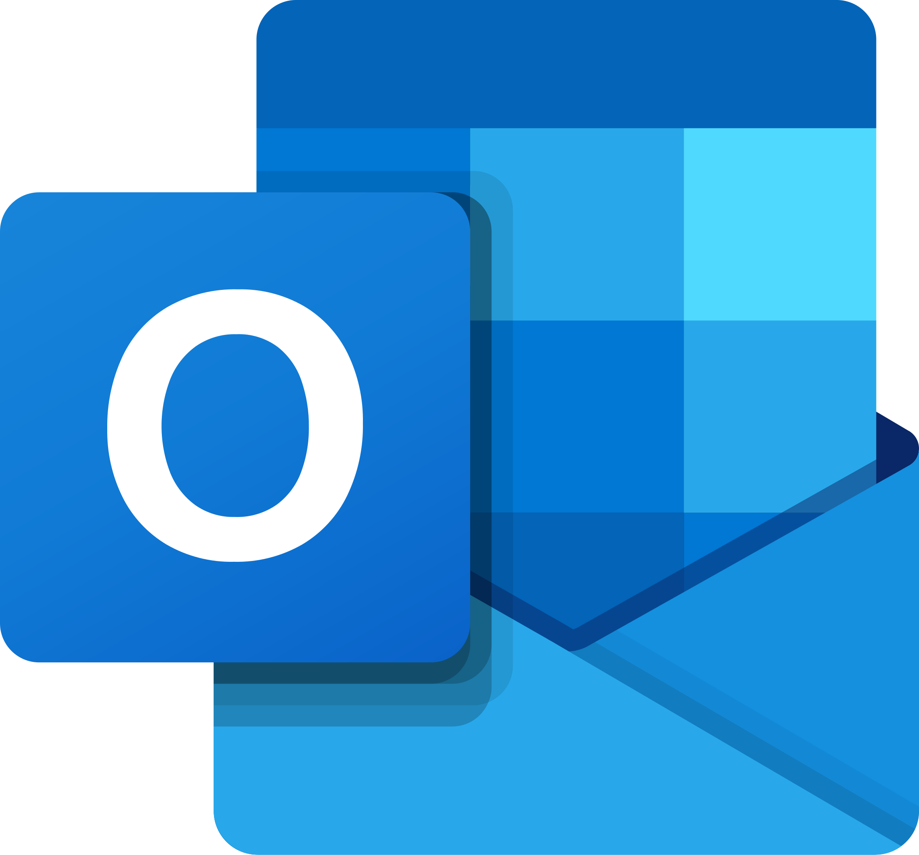

Creating accessible Emails on Ms Outlook
Accessible emails ensure inclusivity for all recipients, including those with disabilities who rely on assistive technologies like screen readers. This toolkit provides step-by-step guidance on crafting accessible emails in Microsoft Outlook, enabling effective communication for diverse audiences.

1. Compose with Accessibility in Mind
- Use Clear and Concise Subject Lines
Write a subject line that describes the email's content effectively (e.g., "Project Update for November").

- Opt for Simple Layouts
Stick to a single-column format to ensure better readability on all devices and for assistive technologies.
2. Use Accessible Text
- Readable Fonts
Use sans-serif fonts like Arial, Calibri, or Verdana in a minimum of 12pt size.

- Sufficient Contrast
Ensure text color contrasts well with the background (e.g., black text on a white background). Avoid overly decorative or script fonts.

- Avoid ALL CAPS
Use headings, bold text, or underline for emphasis instead of all caps, which can be harder to read.
3. Add Alternative Text for Visual Elements
- Images:
- Right-click on the image and select Edit Alt Text.
- Provide a concise description of the image or its purpose (e.g., "Company logo" or "Graph showing sales increase").

- Decorative Images
Mark as decorative if the image doesn’t add meaningful content to the email.

- Emojis and Emticons
Use emojis sparingly, and not in place of words or between words in a sentence.
Avoid text emoticons. Use plain language or emojis instead.
4. Ensure Accessible Links
- Highlight the relevant text (e.g., "Learn more about our services").
- Right-click and select Link to insert the URL.
- Use descriptive phrases instead of generic terms like "Click here."

5. Verify Table Accessibility (if used)
- Use tables only for presenting data, not layout.

- Add a header row:
- Click anywhere in the table.
- Select Table Design on the ribbon.
- Check the Header Row box.
6. Check Accessibility with Outlook’s Built-In Tool
- Open the email draft.
- Go to the Review tab on the ribbon.
- Select Check Accessibility.
- Review the report and address any flagged issues, such as missing alt text or insufficient contrast.
7. Test the Email for Usability
- Preview on Multiple Devices
  - Use the preview option to check how the email displays on desktop, mobile, and tablets.
- Screen Reader Test
  - Send the email to yourself and test with a screen reader like NVDA or JAWS to ensure all content is accessible.
- Keyboard Navigation
  - Confirm that all links and interactive elements can be accessed using only the Tab and Enter keys.
8. Ensure Attachment Accessibility
- Accessible File Formats
  - Attach files in accessible formats, such as tagged PDFs or structured Word documents.
- Descriptive File Names
  - Use clear, descriptive names for attachments (e.g., "Meeting_Agenda_March2024.pdf").
- Provide a Description: Mention the purpose of the attachment in the email body (e.g., "Attached is the agenda for the March meeting.").

Additional Links
Other helpful links for additional information to creating accessible word documents.
- https://www.gov.wales/how-create-accessible-word-documents
- https://webaim.org/techniques/acrobat/
- https://www.adobe.com/accessibility/products/acrobat/using-acrobat-pro-accessibility-checker.html/

