Creating accessible PDFs



PDF accessibility ensures that documents can be used by people with disabilities, especially those relying on assistive technologies such as screen readers, magnifiers, or voice commands.
It matters because it enhances navigation, meets standards and allows everyone to access and interact with information equally.

Making an Existing PDF File Accessible
Proper document properties improve accessibility by providing essential information about the document to screen readers and other assistive technologies.

Adding Accessibility Features in Adobe Acrobat Pro

Run the Accessibility Checker:
- Open the PDF in Adobe Acrobat Pro.
- Go to Tools → Accessibility → Full Check to identify accessibility issues.
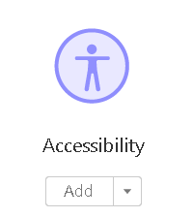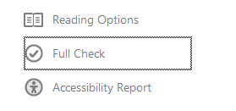
Figure 1 Accessibility Tools Figure 2: Accessibility 'Full Check' command

- Click Full Check (see “Figure 2”) to access the Accessibility Checker Options dialog (see “Figure 3”).

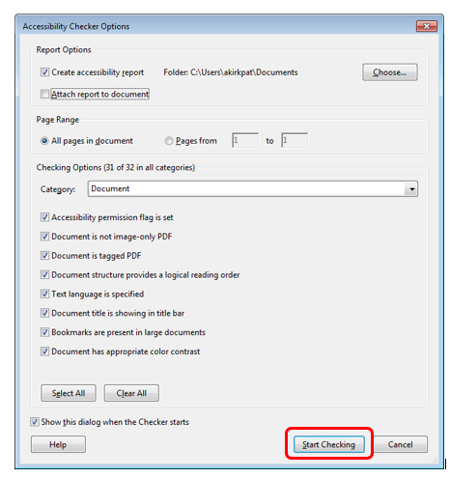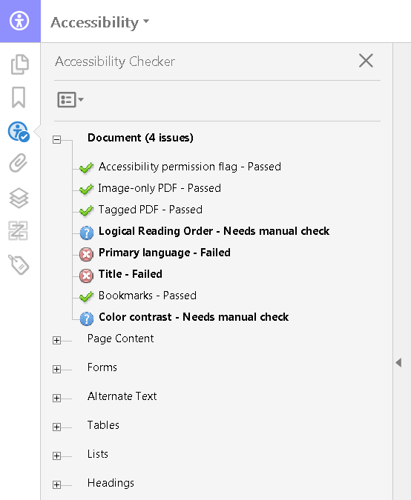
Figure 3 Accessibility Checker Options Dialog Figure 4 Accessibility Checker Panel

- Select All Pages to check the entire document or specify a page range.
- Click Start Checking to begin.

Accessibility Checker Options
The Accessibility Checker (Full Check) has the following options that can be selected under each of the categories listed:
- Document
    - Accessibility permission flag is set
    - Document is not image-only PDF
    - Document is tagged PDF
    - Document structure provides a logical reading order
    - Text language is specified
    - Document title is showing in title bar
    - Bookmarks are present in large documents
    - Document has appropriate color contrast

- Page Content
    - All page content is tagged
    - All annotations are tagged
    - Tab order is consistent with structure order
    - Reliable character encoding is provided
    - All multimedia objects are tagged
    - Page will not cause screen to flicker
    - No inaccessible scripts
    - Navigation links are not repetitive
    - Page does not require timed responses

- Forms, Tables and Lists
    - All form fields are tagged
    - All form fields have description
    - TR must be a child of Table, THead, TBody, or TFoot
    - Tables must have headers
    - Tables must contain the same number of columns in each row and rows in each column
    - Tables must have a summary
    - Figures require alternate text
    - Alternate text that will never be read
    - Alternate text must be associated with some content
    - Alternate text should not hide annotation

Add Tags to the Document:
- If the document lacks tags, go to Tools → Accessibility → Add Tags to Document.
- Review the tags and ensure they correspond to the correct headings, paragraphs, and lists.

Add or Edit Alt Text for Images:
- Right-click an image, select Edit Alt Text, and provide a meaningful description.

Fix Reading Order:
- Use the Reading Order Tool to ensure content is read logically by screen readers.
- Go to Tools → Accessibility → Reading Order, and drag elements to arrange them.

Set Document Language:
- In File → Properties → Advanced, set the document’s primary language.

Ensure Form Fields Are Accessible:
- For interactive forms, ensure fields are labeled properly. Use Prepare Form under Tools to add labels and field names.

Creating an Accessible PDF from Microsoft Office
This section outlines steps to ensure accessibility while preparing and exporting documents from Microsoft Word, PowerPoint, or Excel to PDF.

Preparing the Source Document
- Use Normal style for body text to ensure it’s readable and formatted consistently.
- Avoid manually adjusting spacing; instead, set spacing in Paragraph Settings (right-click on the style and select Modify).

Use Built-in Heading Styles
- Apply hierarchical heading styles (e.g., Heading 1, Heading 2) for proper document structure.
- Avoid changing fonts manually for visual emphasis—use styles instead.
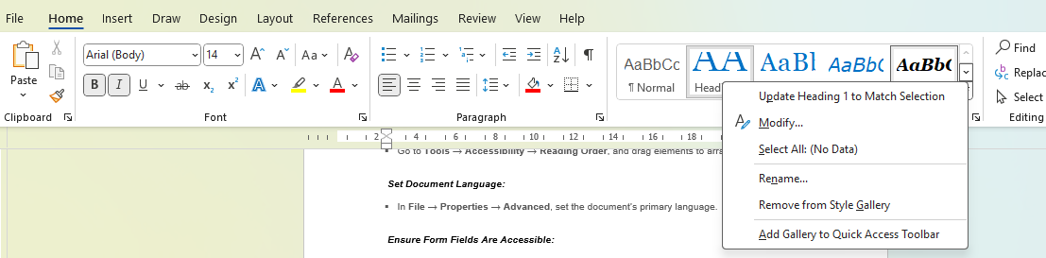

Add Alt Text for Images:
- Right-click an image, select Format Picture, and add alt text describing the image’s purpose.

Use Descriptive Hyperlinks:
- Instead of generic “Click Here,” use links like “Download the Annual Report (PDF).”

Ensure Table Accessibility:
- Use simple tables with clear row and column headers. Avoid merged cells and nested tables.

Check Color Contrast:
- Verify sufficient contrast between text and background (e.g., black text on a white background). Use tools like the WebAIM Contrast Checker.

Run Accessibility Checker:
- In Microsoft Office, go to File → Check for Issues → Check Accessibility to identify and resolve issues.

Exporting the Document to PDF
- Save the document as a PDF using Save As PDF or Export:
- In Word, go to File → Save As → PDF.
- Ensure the “Document structure tags for accessibility” box is checked.
- Verify the PDF tags by opening the exported file in Adobe Acrobat Pro or another PDF editor.
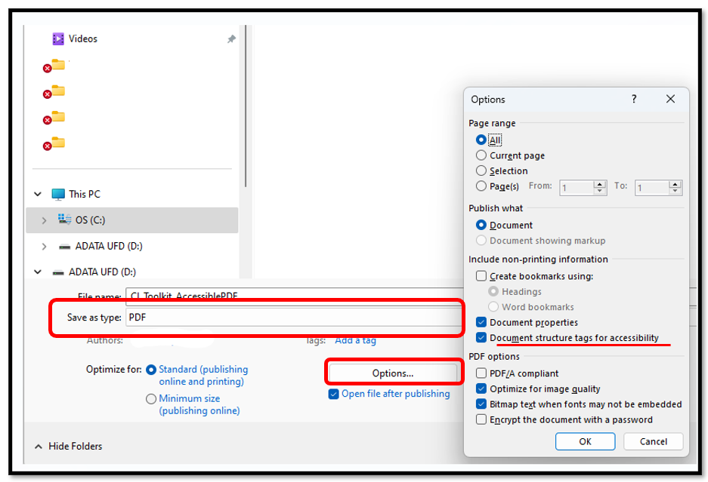

Additional Links
Other helpful links for additional information to creating accessible word documents.
- https://www.gov.wales/how-create-accessible-word-documents
- https://webaim.org/techniques/acrobat/
- https://www.adobe.com/accessibility/products/acrobat/using-acrobat-pro-accessibility-checker.html/

